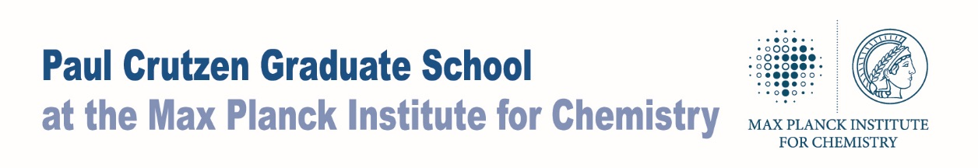
TAC-Meeting
Feedback form

Student’s name
Thesis Title

Department
TAC-committee

PhD start
Please list lectures and schools you visited

Do you expect the student to finish on schedule?  If not, for what reason? | 0 yes  0 no  Remarks:
Is the student able to orally present his/her work adequately? | 0 yes  0 no  Remarks:
Is the student able to present his/her work in writing adequately? | 0 yes  0 no  Remarks:

Do you recommend any soft-skill or language courses?  If yes, which courses? | 0 yes  0 no  Courses:
Is the student actively participating in campaigns? | 0 yes  0 no  Remarks:
Is the student actively involved in seminars? | 0 yes  0 no  0 attending seminars regularly  0 organizing seminars  0 giving talks in seminars  Remarks:
Overall progress of the project so far | 0 Good progress  0 Slow progress  0 Insufficient progress  Remarks:
Participants of TAC-Meeting
Date: | Signature Tutors:  Signature Student:

